**Exercise 2: E-commerce Platform Search Function**

**Product.java**

public class Product {

private String productId;

private String productName;

private String category;

public Product(String id, String name, String category) {

this.productId = id;

this.productName = name;

this.category = category;

}

public String getProductName() {

return productName;

}

@Override

public String toString() {

return "ID: " + productId + ", Name: " + productName + ", Category: " + category;

}

}

**ProductTest.java**

public class ProductTest {

public static void main(String[] args) {

// Create some sample products

Product p1 = new Product("P101", "Laptop", "Electronics");

Product p2 = new Product("P102", "Shampoo", "Personal Care");

Product p3 = new Product("P103", "Notebook", "Stationery");

// Print product details using toString

System.out.println("Product Details:");

System.out.println(p1);

System.out.println(p2);

System.out.println(p3);

// Accessing specific product name

System.out.println("\nAccessing a product name directly:");

System.out.println("Product 1 Name: " + p1.getProductName());

}

}

**Output :**

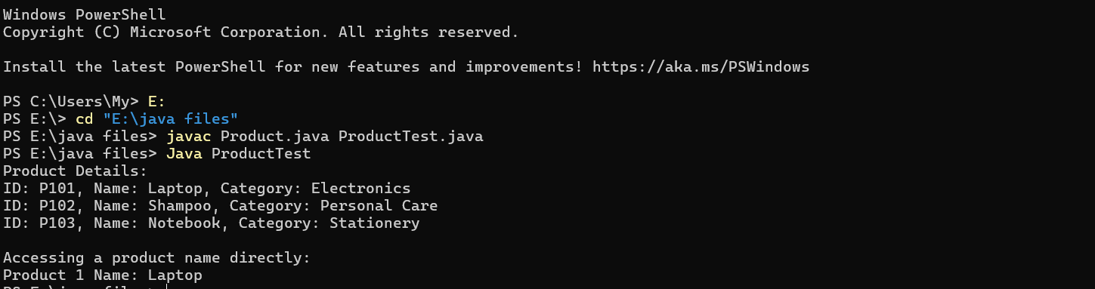

**Exercise 7: Financial Forecasting**

**FinancialForecast.java**

import java.util.Scanner;

public class FinancialForecast {

public static double forecast(double initialAmount, double rate, int years) {

if (years == 0) {

return initialAmount;

}

return forecast(initialAmount, rate, years - 1) * (1 + rate);

}

public static void main(String[] args) {

Scanner scanner = new Scanner(System.in);

System.out.print("Enter initial amount (₹): ");

double amount = scanner.nextDouble();

System.out.print("Enter annual growth rate (e.g., 0.05 for 5%): ");

double rate = scanner.nextDouble();

System.out.print("Enter number of years: ");

int years = scanner.nextInt();

double futureValue = forecast(amount, rate, years);

System.out.printf("Future Value after %d years: ₹%.2f\n", years, futureValue);

scanner.close();

}

}

**Output :**

